Voxels as the standard geometric primitive for 3D-Modelling

**McIntyre, Lewis**

**S2028246**

**Software Development**

lewismcintyre@hotmail.com

[Research Skills Professional Issues (ACG) M3I326557-22-B](https://blackboard.gcal.ac.uk/webapps/blackboard/execute/courseMain?course_id=_115514_1)

2023

Keywords: Voxels, Geometric Primitives, Polygons, Three-Dimensional

Table of Contents

1. Project Proposal 3

2. Contextual Review 4

2.1 Research Question 6

3. Proposed Project 7

3.1 Project Outline 7

3.2 Aim 8

3.3 Objectives 8

3.4 Project Plan 8

4. Ethical Considerations and Professional Issues 9

5. Bibliography 10

5.1 Figures 12

5.2 Abbreviations 12

# 1. Project Proposal

Polygons are accepted as the standard geometric primitive used in 3D modelling; they are defined as any closed shape made up of entirely straight lines on the same plane. Current GPU manufacturers and tech giants have invested heavily into polygons, which originates back to the late 1990s with NVIDIAs GeForce 256. (TheBat!, 2023) It is assumed they were chosen as the standard due to their simplicity and efficiency within computer graphics, but also due to their ability to imitate almost any object. Their most prominent drawback is that they can only ‘*imitate*’ these objects aesthetically. In comparison, voxels or volumetric pixels are used to represent values in three-dimensional space on a regular grid. Voxels function similarly to real particles, therefore making them a more sophisticated implementation used to imitate the real world. They can be viewed as a 3D pixel and have a wide use in procedural generation, particle simulation, and destructive physics. Voxels have had a clear point of contention as the standard rendering practice and have a vast potential in the future of 3D modelling.

Since voxels hold the data of their value in three-dimensional space, they allow efficient usage of Object-Oriented Programming, (OOP) which allows each voxel to hold unique properties. In the case of the 3D voxel game ‘*MakeFarm*’ by David Szymon Grobert, it was used to define if a block is breakable, and if so, should the object then be added to the inventory. (GROBERT, 2023)

Due to polygons being widely accepted as a standard in 3D modelling software, the accessibility of voxels has been significantly limited. Despite this, recent developments have aimed to push forward the boundaries of voxel development. Atomontage is a leader in voxel development with their micro-voxel engine that has been in development since 2010. (Atomontage, 2023) Recently they have showcased their Physically Based Rendering in browser showing control over the creation and destruction of voxels, the Level of Detail (LOD), and various lighting effects. Atomontage are mainly known for their usage of projection based voxelization, soft-body dynamics and their voxel editor’s recent open beta launch in 2021.

Voxel-based modelling has become a powerful tool as an alternative to traditional mesh-based modelling to both the medical and games industries with its advancements in speed and file size. The recent voxel success comes from Teardown, a game made by Tuxedo Labs which features a fully destructible environment, particle simulations of fire and smoke, and hundreds of interesting tools. It has garnered almost 61000 positive reviews. (Tuxedo Labs, 2023) According to the Tuxedo Labs modding wiki, the MagicaVoxel GPU-Based voxel art editor was used to create all 3D models in Teardown. (Tuxedo Labs, 2023)

These tools are incredibly powerful in creating 3D environments; however, they require hundreds of hours in development to take form. A more efficient way of generating 3D models involves Photogrammetry, or the 3D scanning of real-world assets. It has been a term first coined by Sir John Herschel in 1839 and has been said to describe more detail that could normally be done by hand. (Randles , et al., 2010) The most effective way to scan the real-world is the use of LiDAR to generate point clouds. These point clouds can be converted to other model types however are best converted to voxels.

# 2. Contextual Review

As previously discussed, voxels have an incredible potential to change 3D modelling for the computer arts industry. This potential has been recognized in the film industry, where a trend is noticed in favour of the adoption of voxel technology. Its influence has been of note in films such as Rich Moore’s Wreck-it Ralph (2012) and Chris Columbus’ Pixels (2015). (Moore, 2012) (Columbus, 2015) The growing acceptance of voxels within film has the possibility of creating numerous advancements for the techniques used in the 3D modelling of voxels.

The film industry has similar techniques already in use, including photogrammetry, which has been employed in the critically acclaimed The Matrix (1999) and Fight Club (1999). (Wachowski & Wachowski, 1999) (Fincher, 1999) Traditional usage of photogrammetry uses LiDAR Point Clouds to generate its complex 3D models. OpenTopography, a non-profit data centre funded by the National Science Foundation has hundreds of point cloud models taken all over the world. These highly detailed models can be converted into any relevant data type for a variety of use cases, mainly educational or geological studies. (OpenTopography, 2023) Research found by Gebhardt Scott et al. using data gathered and converted from OpenTopography found that the spare and octree voxels compression techniques had a 59x decrease in file size as compared to that of polygons. (Gebhardt, et al., 2009) This data contrasts Miguel Cepero’s ‘*Voxel* Farm’ which took a comparison of both polygons and voxels using in his world. Cepero found that to represent the same level of detail, 40x the voxels were needed as compared to that of polygons. Using an undisclosed compression technique, this came down to voxels using just under 2.4x the file size of its polygonal counterpart. (Cepero, 2023) These differences between file size may be attributed to the differences in the creation of models. In the earlier example, Gebhardt Scott et al. use topographic data gathered using point clouds and uses a conversion technique. This technique is best suited for voxels as each point can be represented as one voxel. Comparatively, Cepero has converted every polygon into its own voxel, and in doing so, may have generated a large amount of unnecessary data. Current implementations of voxels hold more data than polygonal mesh’s as through conversion, the polygon deletes data which cannot be seen converting it to a hollow object. This results in a lower file size and can be seen in Figure 1.

Voxel-to-Mesh Algorithm (Figure 1)

Despite these issues, John Lin, a dedicated game engine developer, has demonstrated the incredibly vast future of voxels with new developments on their own voxel game engine titled ‘*Voxely’*. Current updates show procedurally generated terrain, physical simulations of substances such as water at a per voxel level, and a ground-breaking voxelization method allowing the use of MegaScan and other Quixel assets. (Lin, 2023) Lin has been pushing the boundaries of voxel development since early 2020 with path traced voxel art showing incredible fire animations and leaf simulations. Even though this work is truly incredible, Péter Mileff and Judit Dudra have suggested that it could have been even more efficient. They state in their journal on ‘*Simplified Voxel Based Visualization*’ that:

*‘The field of computer visualization is dominated by the polygon model representations.*’.

(Mileff & Dudra , 2017)

It is then later stated that the favouring of voxels by GPU manufacturers has had a devastating impact on the future of voxels. They suggest the possibility of hybrid rendering technology to use both voxels and polygons and gain benefits only when necessary. For example, the usage of voxels for particle simulations and terrain to allow destructibility. The use of polygons may be used for more complex humanoid creatures that may require soft-body dynamics. This solution is possible in 3D modelling and is already prominent in the film industry using CGI. Nevertheless, it is important to consider a possible visual difference for voxels, particularly in style, as compared to polygons which may need further adjustments.

Voxels are a versatile tool in the field of computer graphics, allowing for a wide range of styles for artists to follow. Some of these include micro-voxels showing an incredible amount of detail simulating real world particles, others being closer to blocky and outdated models with likeness to low-poly assets. A mixture of these two styles will lead you to Marching Cubes, an algorithm published in 1987 for the creation of polygonal models using the isosurface data gathered from 3D volumetric models. (Cline & Lorensen, 1987) (See Figure 2)

(Lague, 2023) (Figure 2)

Each white point in Figure 2 represents a value in three-dimensional space with its own corresponding value, if its value is below surface level, it is deleted, and its corresponding triangles are adjusted. This technique could allow for greater use of hybrid rendering by mixing art styles, however this model will remove many benefits from voxel modelling, some of which includes the real-time destruction and simulation of particles.

There are a variety of voxel compression algorithms that show significant benefits, mainly through a minimized file size and improved performance in scenarios involving large numbers of duplicate voxels or empty space. Some of the algorithms of note include:

Sparse Voxel Compression – This compression algorithm stores only the data of occupied voxels. (See Figure 4)

Octree Voxel Compression – This compression algorithm divides the 3D space into a hierarchy of octants, that are then recursively subdivided into eight until the level of detail required is achieved. (See Figure 5)

Simple Gridded Voxelization (Figure 3)

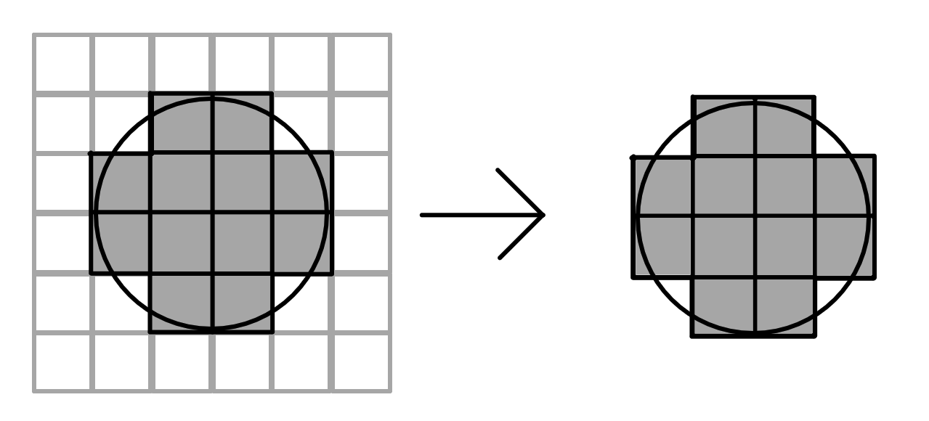

Sparse Voxel Compression (Figure 4)

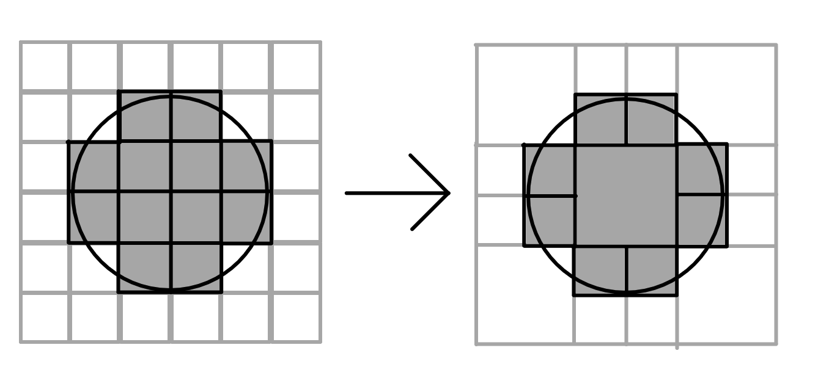

Octree Voxel Compression (Figure 5)

The study by Gebhardt, Scott et al. on the conversion of point cloud data into voxels found that the file size of gridded voxel data was 1250x that of both Sparse Voxels and Octree Voxels. (Gebhardt, et al., 2009) These techniques seem to be efficient in file storage, even without considering newer techniques involve the combination of Sparse and Octree voxels to create Sparse Voxels Octree’s (SVOs). This approach further enhances the already seen benefits of both methods. Using SVOs allows for greater control over the level of detail whilst improving render speeds and file size. However, these benefits are seen only within certain circumstances, for example less benefits would be seen in highly populated models with close to zero empty space or duplication.

Although the compression of voxel data has hundreds of added benefits, there are other techniques used to improve the file size and performance of gridded voxels. Dreams, a voxel-based 3D modelling software released in February of 2020, has implemented sphere tracing, which is a method of rendering voxels to enhance visual quality and smoothen surfaces. This framework was chosen for its benefits in Boolean operations and level of detail adjustments. (Alex Evans, 2015) As of now, Dreams does not offer the ability to export models to other 3D modelling software and therefore, research is limited in terms of its comparative efficiency. However, it can be said that this is still a huge accomplishment, considering the specifications of its platform, the PlayStation 4.

# 2.1 Research Question

Could voxels be a competitor as the standard geometric primitive used in current 3D modelling software?

# 3. Proposed Project

# 3.1 Project Outline

This project has shown the point of contention voxels hold with polygons as the standard geometric primitive used in current 3D modelling software. The advancements shown by John Lin with ‘*Voxely*’, Alex Evans with ‘*Dreams’* and the incredible tools developed over the years for the compression and decompression of voxel data show a positive trend in favour of the voxel’s future. Research from Sebastian Lague, William E. Lorenson and Harvey E. Clint showcase the possibility of voxels near future within the computer arts industry and have garnered many followers because of it. Scott Gebhardt et al., have shown evidence conflicting that of others on the comparison of file sizes for voxels and polygons. (Gebhardt, et al., 2009)

Computational Aesthetics was briefly mentioned by Gebhardt et al. and is important in creating a positive user experience. A separate study on Stimuli Selection to find aesthetic preferences found that 32x32x32 voxel models yielded similar results to its mesh alternative. (Dev, Villar, & Lau, 2017) However, it was also found that 16x16x16 voxels had a lesser preference. The framing of this project is important in determining whether it was successful, as this study suggests the effectiveness of a particular method, may not depend solely on its efficiency but also its aesthetic quality.

To solve the point of contention previously mentioned, the same object with the same level of detail must be used and compared between its voxel and polygonal alternatives. Learning from Gebhardt et al., we should ensure similar levels of detail and any relevant biases found should be explicitly mentioned. The aesthetic preference of each model should also be kept consistent and therefore a 32x32x32 voxel model should be used for any simple models. However, more detail should be shown where appropriate and with specific reasoning (Use for complex models). The Sparse Voxel Octree compression model should also be used as it has been shown to be a revolutionary step for the 3D modelling of voxels.

This project will compare three separate models created in both Sparse Voxel Octree and Polygonal types. The models complexity will start at simple, move on to standard and then onto complex. The models in use will be a standard sphere, a stylized tree and finally a humanoid. Each models counterpart should be aesthetically similar on a 1920x1080 screen. Due to the jagged nature of voxels, their resolution will need to be increased until all possible components of the object are visible. (See Figure 6 & 7)

Voxel Cup (Figure 6)

Polygonal Cup (Figure 7)

The identification of a difference in file size could indicate a possible gain in favour of its relative geometric primitive. This should then provide greater clarity in determining if the voxels are a competitor towards polygons as the standard geometric primitive for 3D modelling. This data may also provide important knowledge which would then be used in future papers on geometric primitives.

The greater clarity in this area should aid industries particularly affected by file storage of models, for example with the previously mentioned LiDAR point clouds, but also within the medical imaging, geological and architectural industries.

# 3.2 Aim

The aim of this project is to add data to the point of contention voxels have with polygons as the standard geometric primitive for 3D modelling software, specifically surrounding the file size of objects, and to evaluate if this data is sufficient evidence to make a definitive point on the comparative effectiveness of voxels and polygons.

# 3.3 Objectives

The objectives of this project are to:

* Generate, validate and analyse each model and their file sizes.
* Evaluate and conclude with reference to the research question.
* After validation and analysis, explicitly mention any bias with suggestions for future improvements.

# 3.4 Project Plan

This project will use three models, created by hand and of three varying types. These include a simple model (A sphere), a standard model (A stylized tree) and a complex model (A humanoid). Each of these will be modelled using the reference images found in Figures 8 through 10.

Simple Sphere (HQ3DMOD, 2023)(Figure 8)

Stylized Tree (Mount3D, 2023) (Figure 9)

Humanoid (WindTrees, 2023)(Figure 10)

The complexity of both the polygonal model and the voxel model will be as complex as needed to describe the crucial elements of each model. For the sphere this is simply its rounded shape, for the stylized tree this is clear branches and leaf size and finally for the humanoid these are the arms, legs, muscle definitions and facial shape. The complexity of each model should not go over their relative intricacy, for example if the pores on the face are not visible on the polygonal surface, they should not be visible on the voxel model.

A quantitative variable will be used to track file size. Any trends or patterns within the datasets will be found to then be both analyzed and evaluated. They will be stored in a table as follows:

|  |  |  |
| --- | --- | --- |
|  | Sparse Voxel Octree (SVO) File Size (MB) | Polygon File Size (MB) |
| Sphere (Simple) |  |  |
| Tree (Standard) |  |  |
| Humanoid (Complex) |  |  |

Data Gathering Table (Figure 11)

# 4. Ethical Considerations and Professional Issues

This project does not plan to use any participants, however if this is to change in the future, a few considerations must be made.

In the situation that participants are needed, they will be screened to ensure they are a consenting ‘*non at risk*’ adult over the age of 18. Then they would be given a form ensuring the understanding of the study, the right to withdraw from the study at any time with all data discarded, and any other relevant factors which could be of ethical concern. Their explicit consent would also be gathered on this form.

All gathered data would be saved anonymously, as well as being stored and deleted in accordance with the General Data Protection Regulation. (GDPR)

All data will be handled with integrity and transparency, with all information being held only for as long as necessary.

The Equality Act of 2010 would also be followed to ensure there are no occurrences of direct or indirect discrimination based on race, gender, disability, marital status, religion/belief, and/or any other protected characteristic.

An ethical approval will not be required as currently there are no participants involved.

# 5.

# Bibliography

Alex Evans. (2015, August 12). Learning from failure. *Advances in Real-Time Rendering in Games. MediaMolecule, SIGGRAPH*, Volume 2.

Atomontage. (2023, May 1). *Home: Atomontage*. Retrieved from Atomontage Web Site: https://www.atomontage.com

Cepero, M. (2023, May 1). *Is Voxel Data bigger than Polygon Data?: Procedural world.* Retrieved from Procedural World Web site: http://procworld.blogspot.co

Cline, H. E., & Lorensen, W. E. (1987, August 01). Marching Cubes: A high resolution 3D surface construction algorithm. *ACM SIGGRAPH Computer Graphics vol. 2 issue. 4*, pp. 163-169.

Coelho, A. B. (2007). Expeditious Modelling of Virtual Urban Environments with Geospatial L-systems. *Computer Graphics Forum Volume 26, Issue 4*, 725-877.

Columbus, C. (Director). (2015). *Pixels* [Motion Picture].

Dev, K., Villar, N., & Lau, M. (2017). Polygons, Points or Voxels? Stimuli Selection for Crowdsourcing Aesthetics Preferences of 3D Shape Pairs. *Symposium on Computational Aesthetics* (pp. 1-7). Los Angeles, California: Association for Computing Machinery, New York, NY, United States.

Fincher, D. (Director). (1999). *Fight Club* [Motion Picture].

Gebhardt, S., Payzer, E., Salemann, L., Fettinger, A., Rotenburg, E., & Seher, C. (2009). *Polygons, Point-Clouds, and Voxels, a Comparison of High-Fidelity Terrain Representations.* Environmental Science.

GROBERT, D. S. (2023). *Implementation of 3D game MakeFarm with infinite terrain model and basic physics in OpenGL API.* Gliwice: Silesian University of Technology.

HQ3DMOD. (2023, May 1). *3D Wooden Sphere Model: Turbosquid.* Retrieved from Turbosquid: https://www.turbosquid.com

Interactive Procedural Street Modeling. (2008). In T. a. SIGGRAPH, *ACM SIGGRAPH 2008 Papers* (pp. 1-10). New York: Association for Computing Machinery.

Jormedal, M. (2013). *Procedural generation of road networks using.* Linköping: Institutionen för systemteknik, Department of Electrical Engineering.

Lague, S. (2023, May 1). *Coding Adventures: Marching Cubes*. Retrieved from Youtube Web site: https://www.youtube.com/

Lin, J. (2023, May 1). *The Perfect Voxel Engine: John Lin's thoughts*. Retrieved from Voxely Web site: https://voxely.net

Mileff, P., & Dudra , J. (2017). Simplified Voxel Based Visualization. *Production Systems and Information Engineering vol. 8*, 5-18.

Moore, R. (Director). (2012). *Wreck-it Ralph* [Motion Picture].

Mount3D. (2023, May 2). *Tree pixel low poly 3D model: Turbosquid.* Retrieved from Turbosquid Models: https://www.turbosquid.com

OpenTopography. (2023, May 1). *Lidar Dataset: Opentopography*. Retrieved from Open Topography Website: https://doi.org/10.5069/G96T0JVW

Parish, Y. I., & Müller, P. (2019). *Procedural Modeling of Cities.* Zürich: ETH Zürich University.

*Procedural Content Generation through Quality Diversity*. (2019, August 20). Retrieved from IEEE Xplore: https://ieeexplore.ieee.org/abstract/document/8848053

RAC Officials. (2018, August 28th). *Where are the longest roads in the UK?* Retrieved from RAC: https://www.rac.co.uk/drive/advice/know-how/longest-roads-in-the-uk/

Randles , B., Welcher, J., Szabo, T., Jones, B., Elliot, D., & MacAdams, C. (2010). *The Accuracy of Photogrammetry vs. Hands-on Measurement Techniques used in Accident Reconstruction.* Detroit, Michigan, United States: SAE International.

TheBat! (2023, May 1). *GeForce 256, GPU Database: Tech Power Up*. Retrieved from Tech Power Up Web site: https://www.techpowerup.com

Transport, D. f. (2021, March 10). *Road lengths in Great Britain* . Retrieved from gov.uk: https://www.gov.uk/government/statistics/road-lengths-in-great-britain-2021/road-lengths-in-great-britain-2021

Tuxedo Labs. (2023, May 1). *Teardown Modding. Tuxedo Labs*. Retrieved from Teardown game website: https://www.teardowngame.com

Tuxedo Labs. (2023, May 1). *Teardown, Steam*. Retrieved from Steam/Valve Corporation. Websitie: https://store.steampowered.com

Wachowski, L., & Wachowski, L. (Directors). (1999). *The Matrix* [Motion Picture].

WindTrees. (2023, May 1). *Male 3D Model: TurboSquid.* Retrieved from Turbosquid: https://www.turbosquid.com

# 5.1 Figures

Figure 1 – An image depicting a voxel-to-mesh algorithm.

Figure 2 – An image taken from Sebastian Lague’s research on optimising the marching cube algorithm for volumetric data. (Lague, 2023)

Figure 3 – An image showcasing an example voxelization method to create a simple sphere of voxels on a grid.

Figure 4 – An image using the voxelated grid from Figure 3 and applying the sparse compression algorithm.

Figure 5 - An image using the voxelated grid from Figure 3 and applying the octree compression algorithm.

Figure 6 – An image showcasing a cup created out of purely voxels.

Figure 7 – An image of a cup created out of polygons.

Figure 8 – An image of a simple sphere model taken from Turbosquid. (HQ3DMOD, 2023)

Figure 9 – An image of a stylized tree taken from Turbosquid. (Mount3D, 2023)

Figure 10 – An image of a humanoid taken from Turbosquid. (WindTrees, 2023)

Figure 11 – A table used to showcase how data will be collected during the project.

# 5.2 Abbreviations

3D – Three-Dimensional

CGI – Computer Generated Imagery

GDPR – General Data Protection Regulation

GPU – Graphics Processing Unit

LOD – Level of Detail

LiDAR – Light Detection and Ranging

OOP – Object Orientated Programming

SVO – Sparse Voxel Octree